using System;  
using System.Collections.Generic;  
using System.Diagnostics.Eventing.Reader;  
using System.Linq;  
using System.Runtime.InteropServices;  
using System.Text;  
using System.Threading.Tasks;  
  
namespace ConsoleRegisterStudent  
{  
    class Program  
    {  
        static void Main(string[] args)  
        {  
            new Program().run();  
  
        }  
  
  
        void run()  
        {  
            int choice;  
            int firstChoice = 0, secondChoice = 0, thirdChoice = 0;  
            int totalCredit = 0;  
            bool yesOrNo;  
            bool complete = false;  
  
            System.Console.WriteLine("Sanders");//added name so it's first line of text  
  
            do// // sets condition to prevent user from picking same course twice  
            {  
                WritePrompt();  
                choice = Convert.ToInt32(Console.ReadLine());  
  
                switch (ValidateChoice(choice, firstChoice, secondChoice, thirdChoice))  
                {  
                    case -1:  
                        Console.WriteLine("Your entered selection {0} is not a recognized course.", choice);  
                        break;  
                    case -2:  
                        Console.WriteLine("You have already registered for this {0} course.", ChoiceToCourse(choice));  
                        break;  
                    case 0:  
                        if (totalCredit == 9)  
                        {  
                            Console.WriteLine("You have reached the maximum credit of 9.");  
                        }  
                        else  
                        {  
                            Console.WriteLine("Registration Confirmed for course {0}.", ChoiceToCourse(choice));  
                        }  
                        break;  
                    default:  
                        Console.WriteLine("Error occurred please try again");  
                        break;  
  
                }  
                if (totalCredit == 9)  
                {  
                    Console.WriteLine("Would you like to exit? (y/n): ");  
                    if (Console.ReadLine() == "y")  
                    {  
                        yesOrNo = true;  
                        Environment.Exit(0); // exits program when user says yes they want to leave the program  
                    }  
                    else  
                    {  
                        yesOrNo = false;  
                    }  
                }  
  
                else  
                    totalCredit += 3;  
  
                if (firstChoice == 0)  
                {  
                    firstChoice = choice;  
                }  
                else if (secondChoice == 0)  
                {  
                    secondChoice = choice;  
                }  
                else if (thirdChoice == 0)  
                {  
                    thirdChoice = choice;  
                }  
                 
                    WriteCurrentRegistration(firstChoice, secondChoice, thirdChoice);  
                    Console.Write("\nDo you want to try again? (y|n)? : ");  
                    if (Console.ReadLine() == "y")  
                    {  
                        yesOrNo = true;  
                    }  
                    else  
                    {  
                        yesOrNo = false;  
                        Environment.Exit(0);  
                    }  
                } while (complete==false);  
             
                Console.WriteLine("Thank you for registering with us");  
            }  
        void WritePrompt()  
        {  
            Console.WriteLine("Please select a course for which you want to register by typing the number inside []");  
            Console.WriteLine("[1]IT 145\n[2]IT 200\n[3]IT 201\n[4]IT 270\n[5]IT 315\n[6]IT 328\n[7]IT 330");  
            Console.Write("Enter your choice: ");  
        }  
  
        int ValidateChoice(int choice, int firstChoice, int secondChoice, int thirdChoice) // with int are return value is expected  
        {  
  
            if (choice < 1 || choice > 7)// deleted 0 here not 70 choices  
            {  
                Console.WriteLine("Unknown number entered please try again");  
                return -1;  
                 
            }  
            else if  
                (choice == firstChoice ||choice == secondChoice || choice == thirdChoice)  // Changed && operator to || because if i don't change the operator i wont get the return values i need  
            {  
                 
                Console.WriteLine("You have selected the same course twice please make another selection");  
                return -2;  
            }  
             
                 
            return 0;// changed from 4  
        }  
  
        void WriteCurrentRegistration(int firstChoice, int secondChoice, int thirdChoice)  
        {  
             
            {  
                if (secondChoice == 0)  
                {  
                    Console.WriteLine("You are currently registered for {0}", ChoiceToCourse(firstChoice));  
                     
                }  
                else if  
                    (thirdChoice == 0) {  
                    Console.WriteLine("You are currently registered for {0}, {1}", ChoiceToCourse(firstChoice), ChoiceToCourse(secondChoice));  
                }  
                else  
                {  
                    Console.WriteLine("You are currently registered for {0}, {1}, {2}", ChoiceToCourse(firstChoice), ChoiceToCourse(secondChoice), ChoiceToCourse(thirdChoice));  
                    //Console.WriteLine("Unknown statement please type again");// comes up incase user types in option not listed  
                }  
  
            }  
        }  
  
        string ChoiceToCourse(int choice)  
        {  
            string course = "";  
            switch (choice)  
            {  
                case 1:  
                    course = "IT 145";  
                    break;  
                case 2:  
                    course = "IT 200";  
                    break;  
                case 3:  
                    course = "IT 201";  
                    break;  
                case 4:  
                    course = "IT 270";  
                    break;  
                case 5:  
                    course = "IT 315";  
                    break;  
                case 6:  
                    course = "IT 328";  
                    break;  
                case 7:  
                    course = "IT 330";  
                    break;  
                default:  
                    break;  
            }  
            return course;  
        }  
  
  
  
  
    }  
}

In the screenshot, you can see the section of code labeled "WriteCurrentRegistration(int firstChoice, int secondChoice, int thirdChoice)" where the if statements are being implemented.  
        {  
             
            {  
                if (secondChoice == 0)  
                {  
                    Console.WriteLine("You are currently registered for {0}", ChoiceToCourse(firstChoice));  
                     
                }  
                else if  
                    (thirdChoice == 0) {  
                    Console.WriteLine("You are currently registered for {0}, {1}", ChoiceToCourse(firstChoice), ChoiceToCourse(secondChoice));  
                }  
                else  
                {  
                    Console.WriteLine("You are currently registered for {0}, {1}, {2}", ChoiceToCourse(firstChoice), ChoiceToCourse(secondChoice), ChoiceToCourse(thirdChoice));

The WriteCurrentRegistration function starts with an if statement to verify if the student is already enrolled in any courses. If so, the chosen classes are listed with commas separating them. Furthermore, there is a boolean variable that asks for a user's input of "yes" or "no" to determine whether they want to repeat the process or not. The return of this prompt is stored in another boolean variable named complete, which is initially set to false.

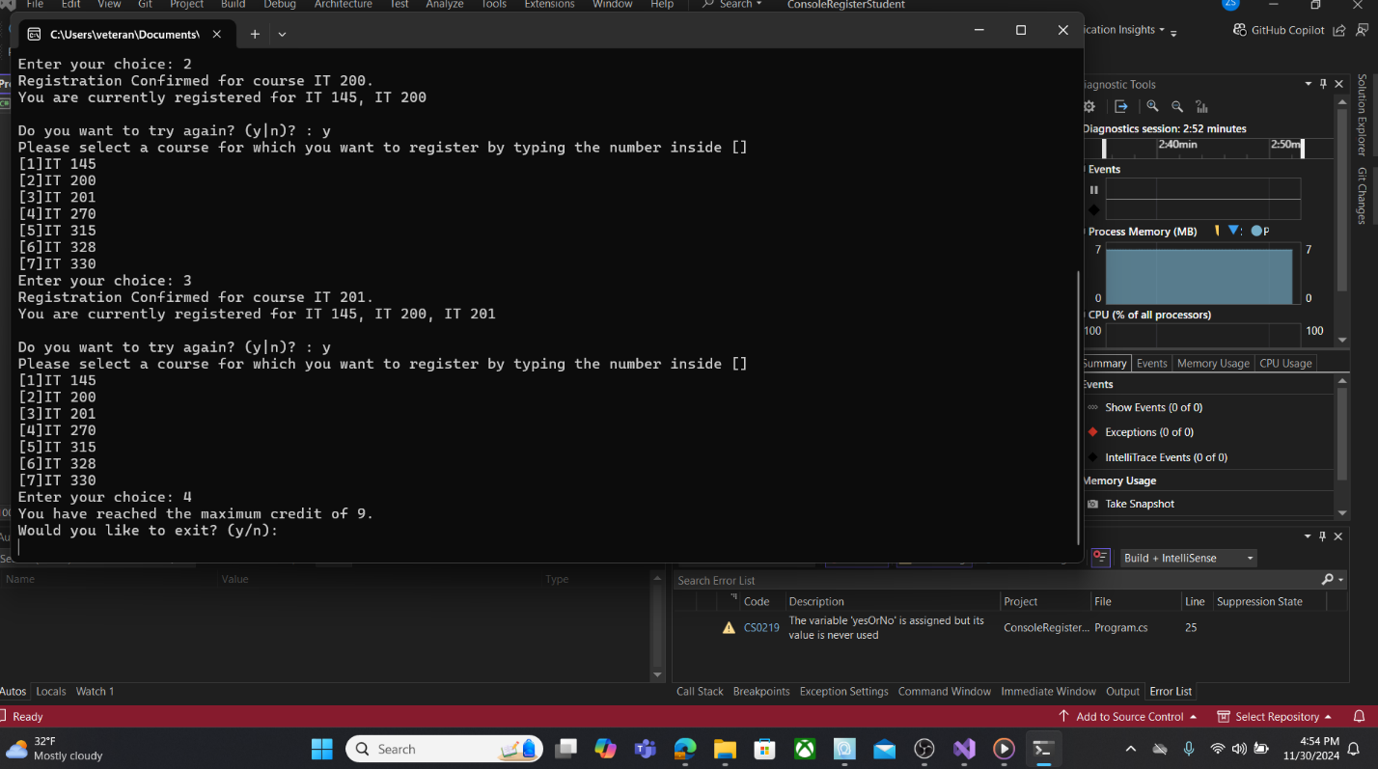

To prevent students from exceeding the maximum of 9 credits, I modified the code within the "WritePrompt" function. By implementing an if statement, I addressed the scenario where a student has already reached their credit limit and attempts to register for another course. The user is also presented with the choice to exit the program by using the bool method bool complete = false;.

case 0:

                        if (totalCredit = = 9)  
                        {  
                            Console.WriteLine("You have reached the maximum credit of 9.");  
                        }  
                        else  
                        {  
                            Console.WriteLine("Registration Confirmed for course {0}.",

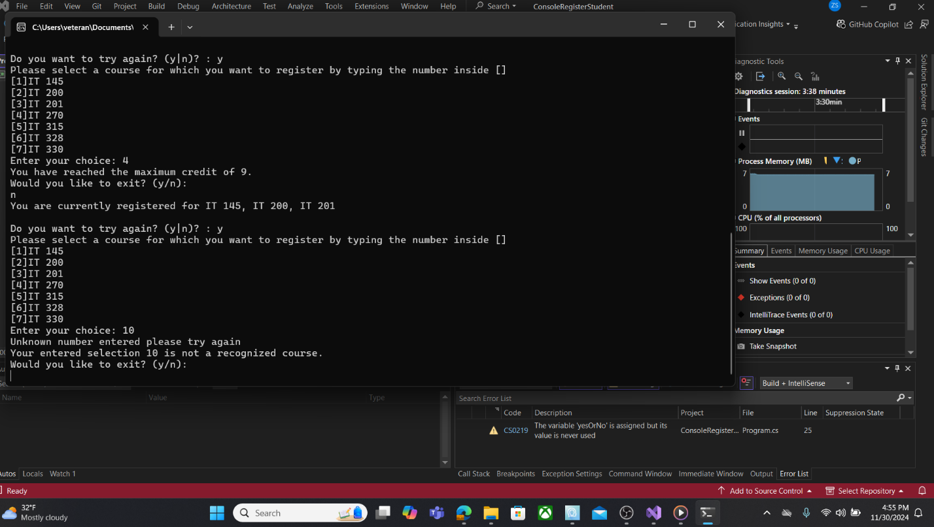

The ValidateChoice method was effectively executed, accepting input numbers between 1 and 7 as valid. If the user enters a number outside of this range, it will be marked as invalid and prompt them to try again. Once the user has made all their course selections, they will not be able to make any further selections and will be prompted to exit the program using the bool method bool complete = false;.

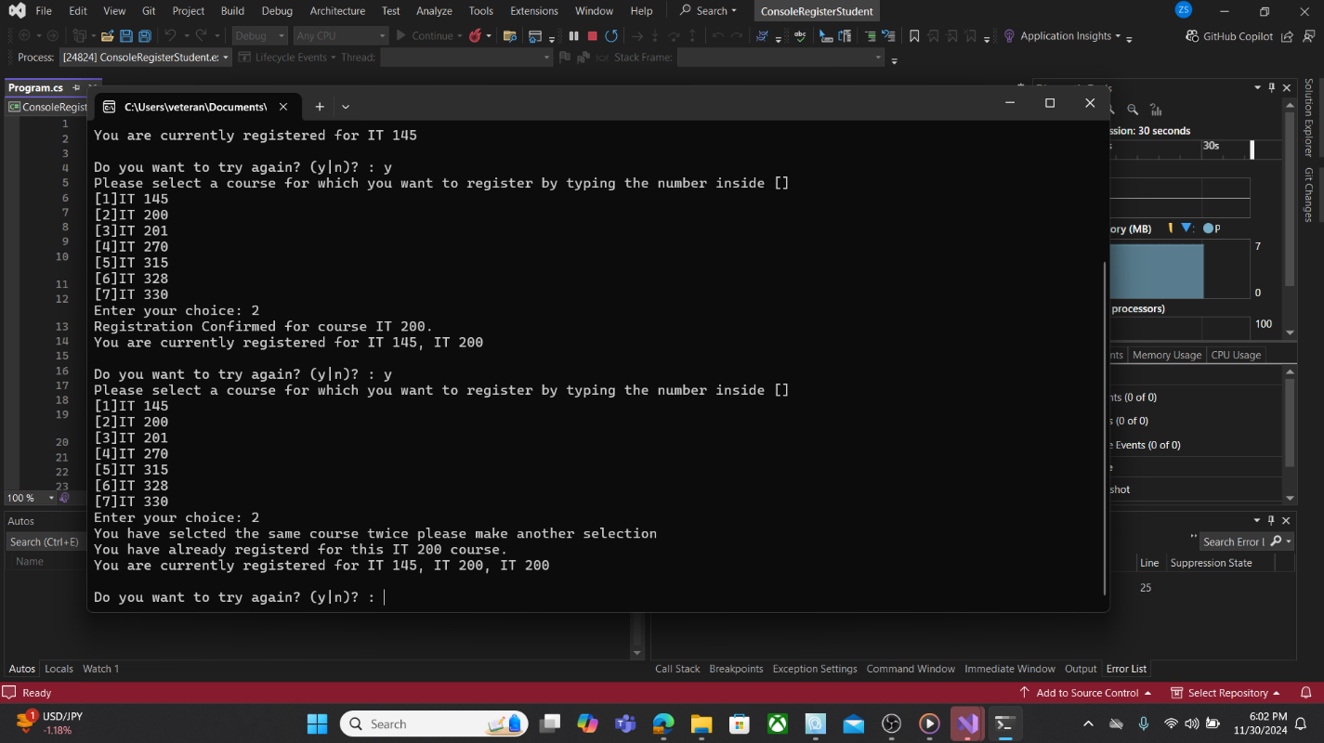

When attempting to enroll in a class that has already been chosen, an error message will appear due to the do statements programmed into the code. The code searches through the list of previously selected courses (firstChoice, secondChoice, or thirdChoice) and compares them to the course you are trying to register for. If there is a match, the code will inform you that you have already selected that course, as well as any others that were previously chosen.